Event Report
Smart India Hackathon 2025 – Internal Round at Nirma University
Date: September 20, 2025
Venue: Nirma University

Introduction:
Entrepreneurship Cell, Nirma University successfully organized the Internal Round of Smart India Hackathon (SIH) 2025, carrying forward its mission to foster innovation, creativity, and problem-solving among students. The event drew an overwhelming response with 1000+ participants and 170 teams registering. After rigorous evaluation, 65 teams were shortlisted to present their innovative solutions before a panel of esteemed mentors.
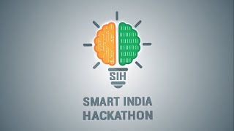

Event Format:
The internal round was structured to mirror the national-level hackathon, giving students an authentic competitive environment. Each team was allotted:
- 5 minutes for presentation
- 4 minutes for Q&A with the panel
To ensure fair and focused evaluations, teams were divided into four parallel panels:
- Panel 1 – Software Projects
- Panel 2 – Software Projects
- Panel 3 – Software Projects
- Panel 4 – Hardware Projects
This structure ensured domain-specific feedback while encouraging teams to present concise, impactful pitches.

Problem Statements and Domains
Participants worked on nationally curated problem statements from government bodies, corporates, and academic institutions. The diversity of topics allowed students to explore challenges of both technological innovation and social impact.
Some representative problem statements included:
- Innovating for Sustainability: Driving Smart Resource Conservation (Godrej Appliances – Hardware & Software)
- Create a Virtual Herbal Garden for Medicinal Awareness (All India Institute of Ayurveda – Software)
- Student Innovation: Smart Education (AICTE – Hardware & Software)
- Student Innovation: Disaster Management (AICTE – Hardware & Software)
- Student Innovation: Blockchain & Cybersecurity (AICTE – Hardware)
This wide variety ensured participation across domains such as AI & automation, MedTech, cybersecurity, sustainable technologies, and digital education.

Mentor Panel
The heart of the event was its esteemed mentor panel, comprising professionals from diverse industries. Their role extended beyond evaluation, they provided constructive feedback, strategic insights, and guidance on scalability and implementation.
Mentors included:
- Mr. Anuj Dalal – Founder & CEO, Zestard Technologies. With vast experience in eCommerce and digital product strategy, he specializes in scaling businesses and aligning digital solutions with market realities.
- Mr. Amish Trivedi – CTO, Upsquare Consulting Services. With deep expertise in software architecture and product life cycle management, he guides startups and enterprises in building scalable, robust digital solutions.
- Mr. Hardik Manwani – Tech Entrepreneur & Consultant, associated with Mind Alcove. His entrepreneurial journey spans web/app solutions, consulting, and startup building, making him well-versed in ideation and execution.
- Ms. Shimoli Shah – VP, Head of Technology at Pacific Group Of Companies. Her deep expertise in product development and providing custom solutions for e commerce and cloud-based enterprises.
- Mr. Parthraj Gohil, Mr. Sohil Patel, and Mr. Ritesh Joshi – Domain Experts. Their backgrounds in technology and consulting enriched the panels with practical, domain-specific perspectives, particularly in software and hardware evaluation.
- Mr. Mosam Gor – Head of Technology, Cohort Social. He brings extensive expertise in technology leadership, software architecture, and strategic direction with a strong entrepreneurial mindset and a deep understanding of product development and growth.
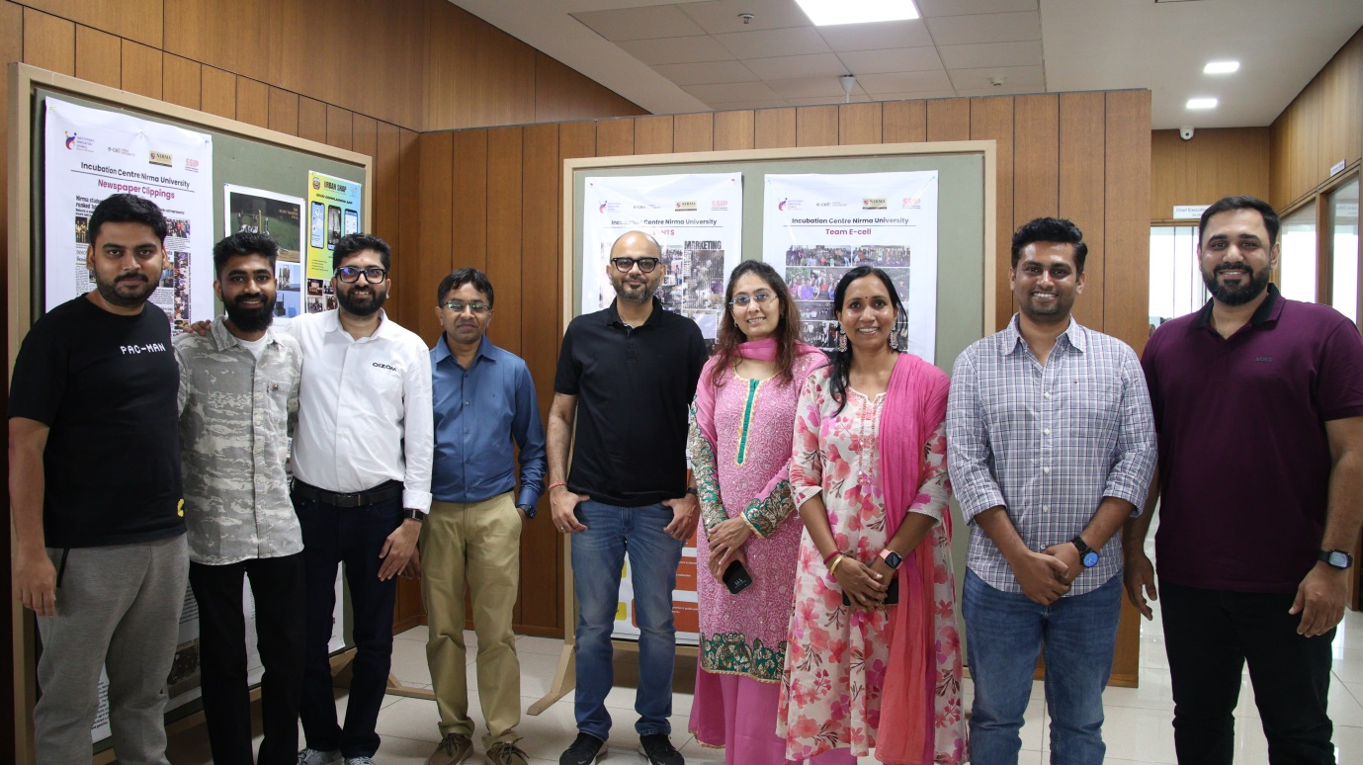
This diverse mentor group ensured that feedback touched on technical strength, scalability, user experience, business viability, and entrepreneurial mindset.

Event Highlights
- 65 shortlisted teams showcased innovations in both hardware and software domains.
- Mentors engaged in interactive Q&A sessions, testing the depth of student knowledge and feasibility of their ideas.
- Teams demonstrated not just technical competence but also teamwork, problem-solving, and entrepreneurial spirit.
- Mentors emphasized cross-domain applications, encouraging participants to broaden the scope of their solutions.
- The event atmosphere was vibrant, with students showing enthusiasm to address real-world challenges.
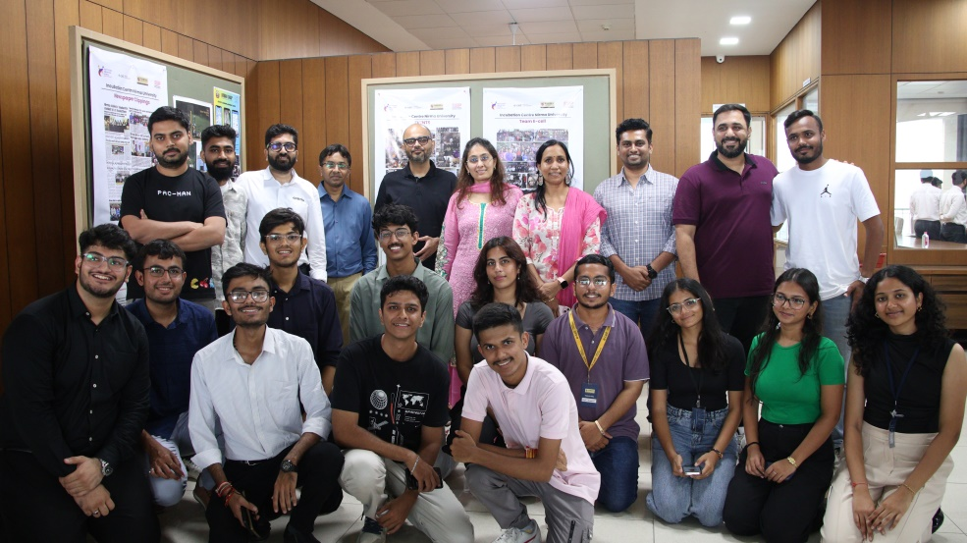

Conclusion
The Internal Round of Smart India Hackathon 2025 at Nirma University was a resounding success. It provided young innovators with the platform, guidance, and exposure needed to shape impactful solutions for real-world problems.
The constructive mentorship, combined with a rigorous presentation format and diverse problem statements, has prepared teams for the upcoming national-level hackathon. The event reaffirmed Nirma University’s vision of empowering students as innovators, problem-solvers, and future change-makers.

